URL: <http://www.stluke.com.ph/>

The 650-bed hospital is home to nine Institutes, 13 Departments, and 19 centers. These centers of excellence bring to the Philippines the latest medical advances and treatment modalities. Over 1,700 hospital-affiliated medical consultants see out-patients in more than 450 private clinics.In 2003, the Joint Commission International (JCI) accredited St. Luke’s Medical Center, affirming that the hospital meets the highest standards for patient care and organizational management. St. Luke’s is the first and only healthcare facility in the Philippines and the second of several in Asia to be accredited by JCI.JCl’s uniform, high quality standards for patient care and safety are designed to be adaptable to local needs, thus accommodating legal, religious and cultural factors within a country.St. Luke's is a special place for healing and a hub of holistic healthcare, providing patients with the best quality healthcare by combining the most advanced medical equipment and technology available with the expertise of the best trained, skilled and experienced doctors and professionals. But its service goes well beyond the dedication of these vital resources.

**VISION**  
  
St. Luke's Medical Center will be one of the Top 5 medical institutions in Asia by Year 2010.  
  
**MISSION**  
  
To deliver excellent healthcare through caring and highly competent professionals, utilizing world-class technology and research. This we shall do in the most financially viable way without losing sight of our primary purpose - to be of service to God and mankind.  
  
**VALUES**

* *Social Responsibility*

The Medical Center ultimately dedicates itself to living up to its responsibility in social service, community health, and environmental safety.

* *Passion for Excellence*

We believe in having a passion for excellence in every aspect of the work we do; in the overall delivery of service to our customers, in ensuring that we meet the highest international standards, and in developing the Medical Center as a world-class institution.

* *Innovation*

We are committed to continuous discovery of new ways by which we can deliver excellent healthcare. We shall openly share our ideas and challenge the status quo knowing that in so doing we will become the best healthcare provider.

* *Customer-Focus*

We are selflessly dedicated to delight our customers, to whom we will provide compassionate and dependable service at the heart of all our endeavors.

* *Expertise*

We shall constantly upgrade our individual and organizational competencies in the areas of service, technology, research, and professional expertise. This will be the key driver to sustain our leadership in the industry.

**Departments:**

St. Luke's 13 Departments assemble traditional medical services into specialties, imparting dedicated medical expertise and support facilities to the areas it cover.

|  |
| --- |
| [Department of Anesthesiology](http://www.stluke.com.ph/index.php?page=parent&pageID=98&parentID=19&xparentID=98) |

|  |
| --- |
|  |
| [Department of Dentistry and Oral Surgery](http://www.stluke.com.ph/index.php?page=parent&pageID=107&parentID=19&xparentID=107) |

|  |
| --- |
|  |
| [Department of Emergency Medicine](http://www.stluke.com.ph/index.php?page=parent&pageID=104&parentID=19&xparentID=104) |

|  |
| --- |
|  |
| [Department of Legal Medicine and Jurisprudence](http://www.stluke.com.ph/index.php?page=parent&pageID=106&parentID=19&xparentID=106) |

|  |
| --- |
|  |
| [Department of Medicine](http://www.stluke.com.ph/index.php?page=parent&pageID=93&parentID=19&xparentID=93) |

|  |
| --- |
|  |
| [Department of Nuclear Medicine](http://www.stluke.com.ph/index.php?page=parent&pageID=64&parentID=19&xparentID=64) |

|  |
| --- |
|  |
| [Department of Obstetrics and Gynecology](http://www.stluke.com.ph/index.php?page=parent&pageID=94&parentID=19&xparentID=94) |

|  |
| --- |
|  |
| [Department of Otorhinolaryngology-Head and Neck Surgery](http://www.stluke.com.ph/index.php?page=parent&pageID=96&parentID=19&xparentID=96) |

|  |
| --- |
|  |
| [Department of Out-Patient Care](http://www.stluke.com.ph/index.php?page=parent&pageID=105&parentID=19&xparentID=105) |

|  |
| --- |
|  |
| [Department of Pediatrics](http://www.stluke.com.ph/index.php?page=parent&pageID=97&parentID=19&xparentID=97) |

|  |
| --- |
|  |
| [Department of Radiation Oncology](http://www.stluke.com.ph/index.php?page=parent&pageID=326&parentID=19&xparentID=326) |

|  |
| --- |
|  |
| [Department of Rehabilitation Medicine](http://www.stluke.com.ph/index.php?page=parent&pageID=99&parentID=19&xparentID=99) |

|  |
| --- |
|  |
| [Department of Surgery](http://www.stluke.com.ph/index.php?page=parent&pageID=95&parentID=19&xparentID=95) |

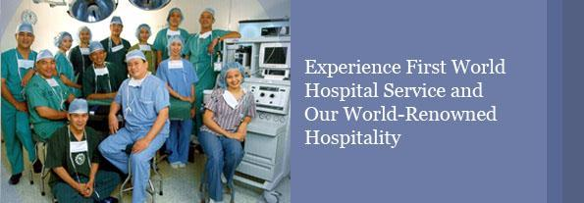

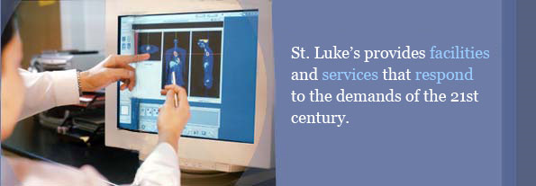



**Contact us:**

St. Luke's Medical Center   
279 E. Rodriguez Sr. Boulevard, Quezon City, 1112 Philippines   
(632) 723-0101 | (632) 723-0301   
E-mail: [info@stluke.com.ph](mailto:info@stluke.com.ph)